Leveraging 3D Displays for Professional Graphics Applications
Contact: harald.steinlechner@aardworx.at, josef.schneider@schneider-digital.com
Draft, 18.2.2022

This document gives an overview of important considerations when preparing graphics applications for use with 3D Displays, in particular Schneider-Digitals Stereo Monitors. While the topic is handled in numerous documents, projects and blogs on the web, the information is often outdated and misses important considerations for practical use. While applications can be rebuilt with particular 3D hardware in mind some rather simple tricks can already provide added-value with relatively little development efforts. There are generally two challenges. Firstly, image or framebuffer data needs to be stored in quad buffers to be used for stereoscopic viewing. The second one is concerned with interaction and perceptual challenges in 3D environments.
First, we will give an overview of how to use Stereo in a modern graphics application and present some low-effort tricks for easier integration. Next, we will summarize some considerations for interactions, UX design and present methods for integrating 2D elements such as windows or cursors in 3D.

Prerequisites

We focus on 3D Displays from Schneider Digital and assume professional graphics card with quad-buffer support. Quad-buffered framebuffers are two double-buffered framebuffers – one for the left and one for the right eye. For each eye we need to generate an image, whereby the two images must use slightly modified view and projection matrices. An excellent description on how to modify the matrices can be found in Grasbergers paper [1]. The eye distance is a very important component for providing proper depth perception. For the mathematical background we also refer to this paper – generally providing a UI element to let users control the eye distance is a good idea.

Utilizing Quad-Buffer Stereo

While there is lot of documentation on how to enable quad-buffered stereo in plain OpenGL, these descriptions are often out-of-date and do not integrate well with modern OpenGL 4.0 programming style.
Clearly, the standard technique is to render the scene twice. This method is very simple and can for example be seen in this example [2].
For high-demanding graphics applications this approach is suboptimal since the scene needs to be rendered twice. For CAD applications dealing with high polygon counts, most of the work is thus duplicated – this is particularly problematic in fully immersive setups, or when using VR input devices, since a low framerate breaks immersion.

Recently, due to increasing popularity in consumer VR markets, special graphics card features have been introduced to improve on this – the idea behind those approaches is to render both images in a single pass (single pass rendering).
The first technique, which can be very lightweight and effective is to utilize layered rendering [3], that is, instead of rendering into a single framebuffer, multiple framebuffers can be written simultaneously. A geometry shader can then be used to replicate each primitive, transform it with the left and the right view-projection matrix and use the gl_Layer intrinsic to specify the target framebuffer index.
After rendering to the image array, the images need to be copied to the quad buffers accordingly, e.g. using glDrawBuffer and glBlitframebuffer.

Integration with Vulkan

If you are using Vulkan, there is no direct support for quad-buffer stereo. The easiest approach is to render to images using layered rendering. Notably, OVR_multiview [4] could be used instead of geometry shader replication of triangles.
The textures can be shared using external images [5] with OpenGL, which allows to blit the framebuffers to GL_BACK_RIGHT and GL_BACK_LEFT.
Note that the textures need to be synchronized using semaphores (or similar). We can provide more information on-demand on this matter.
The same technique also applies to integration with DirectX.

Integrating UI with 3D Viewing

Having properly calibrated 3D images is the basis for added-value of 3D displays, however, interactions and UX are equally important.
In real-world scenarios, user interfaces need to be integrated with the stereo view. To give an idea, we list some options we explored:
- Leave the UI as-is and separate it from the 3D view clearly. If there is picking on scene objects involved, it is highly beneficial to turn off the mouse cursor when hovering the 3D view. See the next chapter for more details on picking.
- Render the UI into a texture and integrate it with the 3D view by directly rendering the UI as textured quads at a defined depth.

- Provide a separate UI, which integrates with the 3D View. This is particularly interesting when parts of the UI can be implemented as HTML pages – this way, streaming browser content into a texture provides good flexibility. Since not the complete UI needs to be ported to 3D, this approach is particularly interesting.

Integrating Picking with 3D Views

As mentioned before, in the 3D view the cursor of the operating system should be disabled. Since the default operating system cursor is duplicated into both framebuffers automatically it is not possible to adjust disparity. To better integrate the cursor into the 3D scene and not to break immersion a custom cursor is highly recommended..
The easiest solution is to explicitly render a cursor at the correct depth manually. The most simple solution is to use a textured quad with a texture of a cursor.
Which depth is the correct depth then? The cursor, as an actual object in 3D, should have similar depth as the object users are pointing at. If your rendering engine or scene data structure supports ray picking, clearly a pick-ray could be computed using either the left, or the right view/projection matrices. Given this, the 3D coordinate of the hit point can be used to render the cursor.
Another option is to use depth readback from a framebuffer. In graphics applications which render directly to the framebuffer (i.e. no deferred pipeline), a simple glReadPixels suffices to read back the depth value. Depending on the conventions used in the graphics API and the matrices, the pixel can be unprojected using:
// compute normalized device coordinate
ndc = (mousePos.X / viewportSize.X, mousePos.Y / viewportSize.Y, d * 2.0 – 1.0)
p = viewProj.Inverse * ndc // backproject
worldPos = p.XYZ / p.W // perspective division
For deferred pipelines, reading back could for example be done using glGetTexImage. While the download introduces a CPU synchronization point, often this is not a problem in professional applications.
Clearly there are better, less conventional approaches to 3D cursors depending on the data. For example, for polygonal 3D geometry a virtual sphere projected onto the surface to create a footprint can provide good depth-perception (see Figure 1).
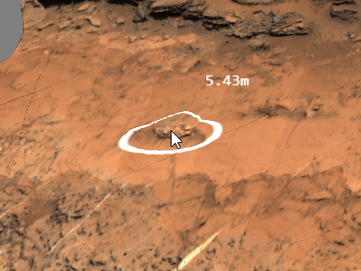
Figure 1 "Footprint Cursor” combined with the standard windows cursor Pro3D [7]. This approach is easily portable to 3D.
Such effects can be achieved solely in the pixel shader. Given the world space cursor position, the distance of the fragment position to the cursor position can be computed and thus used for colorizing the pixel. In order not to suffer from shader aliasing, the smoothstep [9] function can be used to model smooth thresholds.
A similar technique can be used for volumetric data. Figure 2 shows the selection of a pore in 3D volumetric data. Instead of having a pointer-like cursor, pores “under” the cursor are colored in red. This technique is very similar to the previously mentioned approach. Given the cursor’s world-space coordinates, the distance of the voxel to be shaded and the cursor can be computed directly in the shader in order to colorize voxels within a distance to the cursor position.
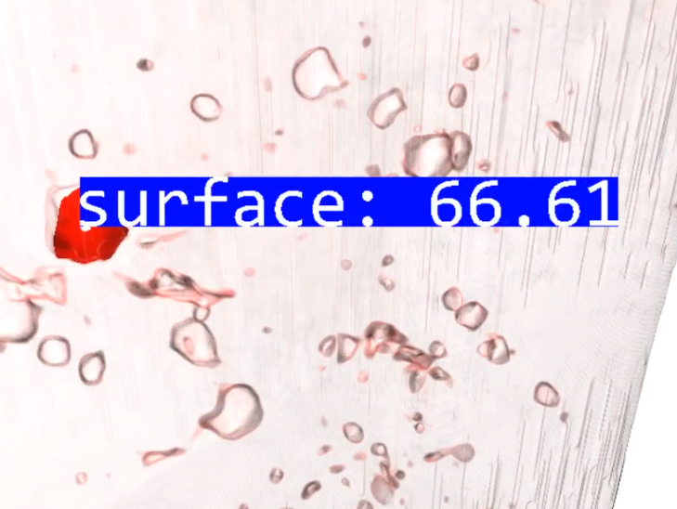
Figure 2 Billboard (3D) with selected pore of casting part in Aardworx Volume Renderer [8]. For 3D viewing the billboard should be placed at proper depth.
Another option is to use polygonal objects instead of a 2D cursor or modified shading (see Figure 3).
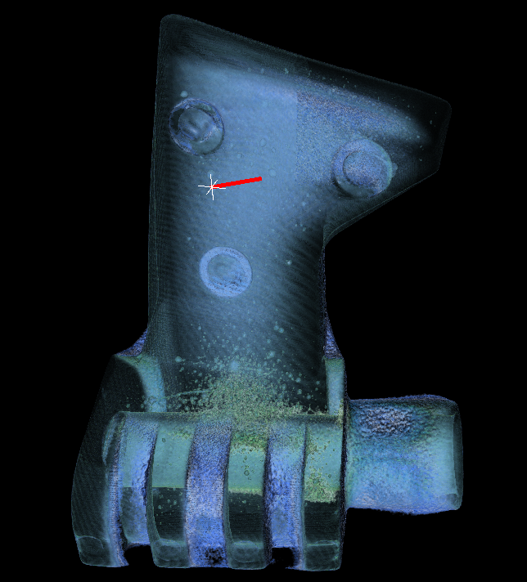
Figure 3 Zink casting part in 3D. Cursor Cross, rendered at correct depth and measurement line in Aardworx Volume Renderer [8]. This technique works good in 3D display settings.

Advanced Topics

When using the readback technique, clearly the back projected world space coordinate always exactly matches the pixel under the mouse. However, when using a cursor representation larger than a single pixel, the cursor might get occluded in the surrounding when depth testing is enabled. The situation is given in Figure 4. In their study Schemali and Eisemann find that rotating the cursor and using a circle pointer improves usability.
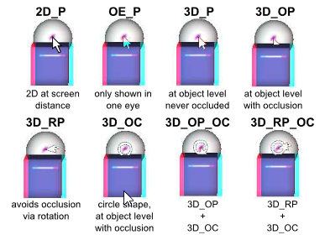
Figure 4 Problems of cursors as analyzed by Schemali and Eiseman [10]

Beyond picking and mouse interactions for pointing and selection, there is a lot of research in the field of virtual reality tackling interactions using virtual reality devices and tracking. Natalia et al. [13] for example present a study on how to integrate 2D and 3D interactions for modelling applications.

Conclusion

Clearly there is a large design space. Generally, it is preferrable to render only real 3D entities in stereo mode. Just by rendering the cursor at proper depth, the immersion can be improved largely. However, for better depth-perception, integrated approaches such as rendering real 3D objects further improves the immersion and thus the value added by the 3D display technology. Also, when considering performance, it is well worth looking into single-pass methods for rendering stereo images as described in this document.

References

[1] Grasberger, Introduction to Stereo Rendering, https://www.cg.tuwien.ac.at/research/publications/2008/Grasberger_2008_ISR/Grasberger_2008_ISR-Paper.pdf
[2] https://github.com/iebeid/quad-buffered-stereo/blob/fe72d5813500df751a899b86c30826fae9186b0b/ipers_stereo.c#L497
[3] https://www.khronos.org/opengl/wiki/Geometry_Shader#Layered_rendering
[4] https://www.khronos.org/registry/OpenGL/extensions/OVR/OVR_multiview.txt
[5] https://www.khronos.org/registry/vulkan/specs/1.3-extensions/html/vkspec.html#VkPhysicalDeviceExternalImageFormatInfo
[6] https://github.com/aardvark-community/aardium
[7] https://pro3d.space/
[8] https://www.aardworx.at/
[9] https://www.khronos.org/registry/OpenGL-Refpages/gl4/html/smoothstep.xhtml
[10] Design and Evaluation of Mouse Cursors in a Stereoscopic Desktop Environment, Schemali and Eisemann, https://hal.archives-ouvertes.fr/hal-01026538/document
[11] Teather, Stuerzlinger, Depth Cues and Mouse-Based 3D Target Selection https://www.csit.carleton.ca/~rteather/pdfs/SUI2014_poster1.pdf
[12] Azari, Cheng, Basu, Stereo 3D Mouse Cursor: A Method for Interaction with 3D Objects in a Stereoscopic Virtual 3D Space, https://www.hindawi.com/journals/ijdmb/2010/419493/
[13] Bogdan, Grossman, Fitzmaurice, HybridSpace: Integrating 3D Freehand Input and Stereo Viewing into Traditional Desktop Application https://damassets.autodesk.net/content/dam/autodesk/research/publications-assets/pdf/hybridspace-integrating-3d-freehand.pdf

